Jason Cromer

Math 324, Section 0

2/7/16

Homework Plots

Chapter 1.2:

#11.a

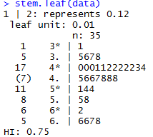

Chapter 1.3:

#36.a

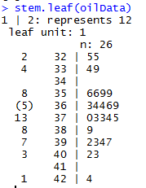

Chapter 1.4:

#55.c

